//a [@class='btn btn-lg btn-success']

2.

//div [@class='masthead']

3.

//\*[@role='button']//preceding::a

4.

//div[@class='row']/preceding-sibling::div

5.

//div[@class='row']/following-sibling::div

6.

//div[@class='row']/following::div

7.

/html[1]/body/div[@class='container']/div[@class='row']/div[@class='col-md-4']

8.

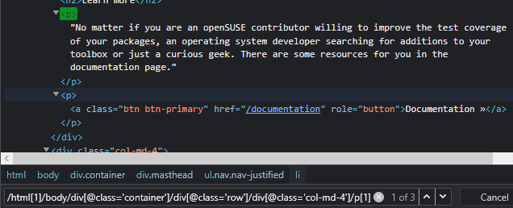

/html[1]/body/div[@class='container']/div[@class='row']/div[@class='col-md-4']/p[1]

9.

//h2[text()=’Join’]

10.

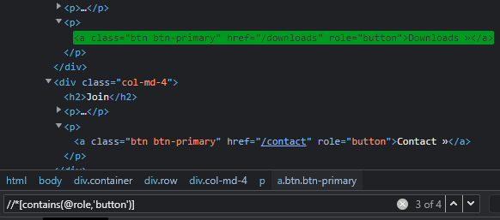

//\*[contains(@role,'button')]

11.

//\*[@role='button' or @role='row']

12.

//\*[@class='btn btn-primary' and @role='button']